UNIVERSITY OF CALCUTTA

DIGITAL IMAGE PROCESSING

Msc. Computer and Information Science
Semester- II
Roll-No :- 91/CIS/091007
Registration No :- 0000439 OF 2006-2007
Paper :- CISM-205(P)

CONTENT
Sl. No. | Assignment | Page No.
1 | ZOOMING AND SHRINKING DIGITAL IMAGES
 | Theory | 3
 | Algorithm | 4
 | Code | 5-11
 | Input/Output | 12
 | Discussion | 13
2 | HISTOGRAM EQUALIZATION OF DIGITAL IMAGES
 | Theory | 14
 | Algorithm | 15
 | Code | 16-23
 | Input/Output | 24
 | Discussion | 25

ZOOMING AND SHRINKING DIGITAL IMAGES
Theory:-
Zooming and Shrinking of digital images is related to Image Sampling and Quantization.Zooming may be viewed as oversampling and shrinking may be viewed as undersampling.

ZOOMING:
Zooming requires two steps:
- The creation of new pixel locations
- The assignment of gray levels to those new locations.

Example:
Suppose that we have an image of size 500*500 pixels and we want to enlarge it 1.5 times to 750*750 pixels.
Conceptually, one of the easiest ways to visualize zooming is laying an imaginary 750*750 grid over the original image. Obviously, the spacing in the grid would be less than one pixel because
We are fitting it over a smaller image. In order to perform gray-level assignment for any point in the overlay, we look for the closest pixel in the original image and assign its gray level to the new pixel in the grid. When we are done with all points in the overlay grid, we simply expand it to the original specified size to obtain the zoomed image.
This method of gray-level assignment is called nearest neighbor interpolation.

SHRINKING:
Image shrinking is done in a similar manner as just described for zooming
Example

To shrink an image by one-half, we delete every other row and column.
We can use the zooming grid analogy to visualize the concept of shrinking by a non integer factor :
- we now expand the grid to fit over the original image
- do gray-level nearest neighbor or bilinear interpolation, and then shrink the grid back to its original specified size.
- To reduce possible aliasing effects, it is a good idea to blur an image slightly before shrinking it.

Algorithm:-
Step 1:- Take a sample JPEG Image file ‘ImageOriginal’ from the user.
Step 2:- Create a ‘ImageBuffer’ in the memory and place the ‘ImageOriginal’ in the image buffer.
Step 3:- Find the Height and Width of the image file ‘ImageOriginal’ and assign then to variables height and width respectively.
Step 4:- Take the ‘zoom_factor’ or ‘shrink_factor’ from the user as an Input.
Step5:- Perform nearest neighbor interpolation for each pixel position of the ‘ImageOriginal’ depending on the ‘zoom_factor/shrink_factor’.
ZOOMING:
Step 5.1:- Find out the RGB value for each pixel(i/zoom_factor,j/zoom_factor)
Step 5.2:- Assign the RGB value for each pixel(i, j) for the ‘New_Zoomed_Image’.
Step 5.3:- Create New_Buffer_Space for the ‘New_Zoomed_Image’ having dimensions
New_Height= height * zoom_factor
New_Width= width * zoom_factor

SHRINKING:
Step 5.1:- Find out the RGB value for each pixel(i*Shrink_factor, j*Shrink_factor)
Step 5.2:- Assign the RGB value for each pixel(i, j) for the ‘New_Shrinked_Image’.
Step 5.3:- Create New_Buffer_Space for the ‘New_Shrinked_Image’ having dimensions
New_Height= height/Shrink_factor
New_Width= width/Shrink_factor

Step 6:- Draw the New_ Zoomed/Shrinked Image.
Step 7:- End

Code:-

/*Assignment 1:-Zooming and Shrinking of a Digital Image*/
package ImageProcessingAssignments;

/*Import JAVA and JAVAX packages*/
import java.awt.*;
import java.io.*;
import javax.swing.*;
import java.awt.event.KeyEvent;
import java.awt.event.KeyListener;
import java.awt.image.BufferedImage;
import javax.imageio.ImageIO;

/*Declaring the main class that extends JPanel and implements KeyListner*/
public class ZoomShrink extends JPanel implements KeyListener
{
private static final long serialVersionUID = 1L;

/*Declaring BufferImage variables which will store the original image and the modified image*/
//Stores the original image
BufferedImage imageOld;
//Stores the new image
BufferedImage imageNew;

/*Declaring variables which will be used for creating the new image*/
//Stores the width of the image
public static int width = 0;
//Stores the height of the image
public static int height = 0;
//Stores the pixel intensity of the image
public static int val = 0;
//Zoom factor in the x direction
public static int zoomx = 1;
//Zoom factor in the y direction
public static int zoomy = 1;
//Shrink factor in the x direction
public static int shrinkx = 1;
//Shrink factor in the y direction
public static int shrinky = 1;
//Flag to modify the factors for zooming
public static int flags = 1;
//Flag to modify the factors for shrinking
public static int flagz = 1;

/*Constructor to initialize the variables of the class*/
public ZoomShrink(BufferedImage imageOld)
{
//Initialize the original image
this.imageOld = imageOld;
//Initialize the new image
this.imageNew = imageOld;

//Initialize the width of the image
width=imageOld.getWidth();
//Initialize the height of the image
height=imageOld.getHeight();
}

/*Function to reload the image for repainting the screen*/
public void LoadBuffer()
{
//Create the buffer space for the new image to be drawn on the screen for zooming
if(flagz == 1)
{
try
{
this.imageNew = new BufferedImage(imageOld.getWidth()*zoomx,imageOld.getHeight()*zoomy,BufferedImage.TYPE_INT_RGB);
}
catch(Exception e)
{
}
}

/*Create the buffer space for the new image to be drawn on the screen for shrinking */
if(flags == 1)
{
try
{
this.imageNew = new BufferedImage(imageOld.getWidth()/shrinkx,imageOld.getHeight()/shrinky,BufferedImage.TYPE_INT_RGB);
}
catch(Exception e)
{
}
}
}

/*Function which is called to paint the screen to display the images at regular intervals*/
protected void paintComponent(Graphics g)
{
/*Passing the graphics display screen components to the superclass function to be displayed on the screen area*/
super.paintComponent(g);

/*Calling the function that creates the new image depending on the user's key input*/
makeImage();

//Calling the function that draws the images on the screen
drawImages(g);
}

/*Function to create the new image*/
private void makeImage()
{
//Declaring local variables
int i = 0,j = 0;

//For zooming the image
if(flagz == 1)
{
for(i = 0;i < width*zoomx;i++)
{
for(j = 0;j < height*zoomy;j++)
{
/*Reading the value at particular pixel position in the original image which is close to the pixel position in the new image*/
val = imageOld.getRGB(i/zoomx,j/zoomy);
//Mapping the value obtained to the new image
imageNew.setRGB(i,j,val);
}
}
}

//For shrinking the image
if(flags == 1)
{
for(i = 0;i < width/shrinkx;i++)
{
for(j = 0;j < height/shrinky;j++)
{
/*Reading the value at particular pixel position in the original image which is close to the pixel position in the new image*/
val = imageOld.getRGB(i*shrinkx,j*shrinky);
//Mapping the value obtained to the new image
imageNew.setRGB(i,j,val);
}
}
}
}

/*Function to draw the images on the screen*/
private void drawImages(Graphics g)
{
/*Setting the color,font,font type and font size for the text to be displayed on the screen */
g.setColor(Color.magenta);
g.setFont(new Font("Arial",Font.BOLD,20));

//Displaying the original image at a particular screen location
g.drawString("Original Image",18,18);
g.drawImage(imageOld,20,30,this);

//Displaying the new image at a particular screen location
g.drawString("Changeing Image",100+width,20);
g.drawImage(imageNew,108+width,30,this);

/*Setting the color,font,font type and font size for the text to be displayed on the screen */
g.setColor(Color.black);
g.setFont(new Font("Arial",Font.PLAIN,22));

//Displaying the key controls to help the user
g.drawString("Key Controls",100,900);
g.drawString("Page UP:- Zoom In",100,920);
g.drawString("Page DOWN:- Zoom Out",100,940);
}

/*Function that detects the key pressed*/
@Override
public void keyPressed(KeyEvent Key)
{
/*If PAGE UP key is pressed then for zooming the factors are changed accordingly*/
if(Key.getKeyCode() == KeyEvent.VK_PAGE_UP)
{
/*Checking if the original image has been shrinked then modify on the new image else on the old image*/
if(flags == 1)
{
if(shrinkx > 1)
{
shrinkx-=1;
shrinky-=1;
flags = 1;
flagz = 0;
}
else
{
zoomx+=1;
zoomy+=1;
flagz = 1;
flags = 0;
}
}

else
{
zoomx+=1;
zoomy+=1;
flagz = 1;
flags = 0;
}
LoadBuffer();
repaint();
}

/*If PAGE DOWN key is pressed then for shrinking the factors are changed accordingly*/
if(Key.getKeyCode() == KeyEvent.VK_PAGE_DOWN)
{
/*Checking if the original image has been zoomed then modify on the new image else on the old image*/
if(flagz == 1)
{
if(zoomx > 1)
{
zoomx-=1;
zoomy-=1;
flagz = 1;
flags = 0;
}
else
{
shrinkx+=1;
shrinky+=1;
flags = 1;
flagz = 0;
}
}
else
{
shrinkx+=1;
shrinky+=1;
flags = 1;
flagz = 0;
}
LoadBuffer();
repaint();
}
}

@Override
public void keyReleased(KeyEvent arg0)
{
}

@Override
public void keyTyped(KeyEvent Key)
{
}

/*Main function*/
public static void main(String[] args)
{
/*Loading the image path on which the actios of zooming and shrinking will be done*/
String path = "C:\\images\\02.png";
//Creating a local buffer image in which the image will be loaded
BufferedImage image = null;

//Loading the image onto the buffer
try
{
image = ImageIO.read(new File(path));
}
catch(IOException e)
{
System.out.println("Cannot Read File at location :-"+path);
}

//Initializing the class image variable
ZoomShrink obj = new ZoomShrink(image);
//Creating the frame on which the image will be displayed
JFrame frame = new JFrame("Zooming & Shrinking");
//Setting the default close option
frame.setDefaultCloseOperation(JFrame.EXIT_ON_CLOSE);
//Adding the class object to display the image
frame.add(obj);
//Maximizing the frame by default
frame.setExtendedState(Frame.MAXIMIZED_BOTH);
//Adding the key listener to the frame
frame.addKeyListener(obj);
//Setting the visibility of the frame
frame.setVisible(true);
}
}

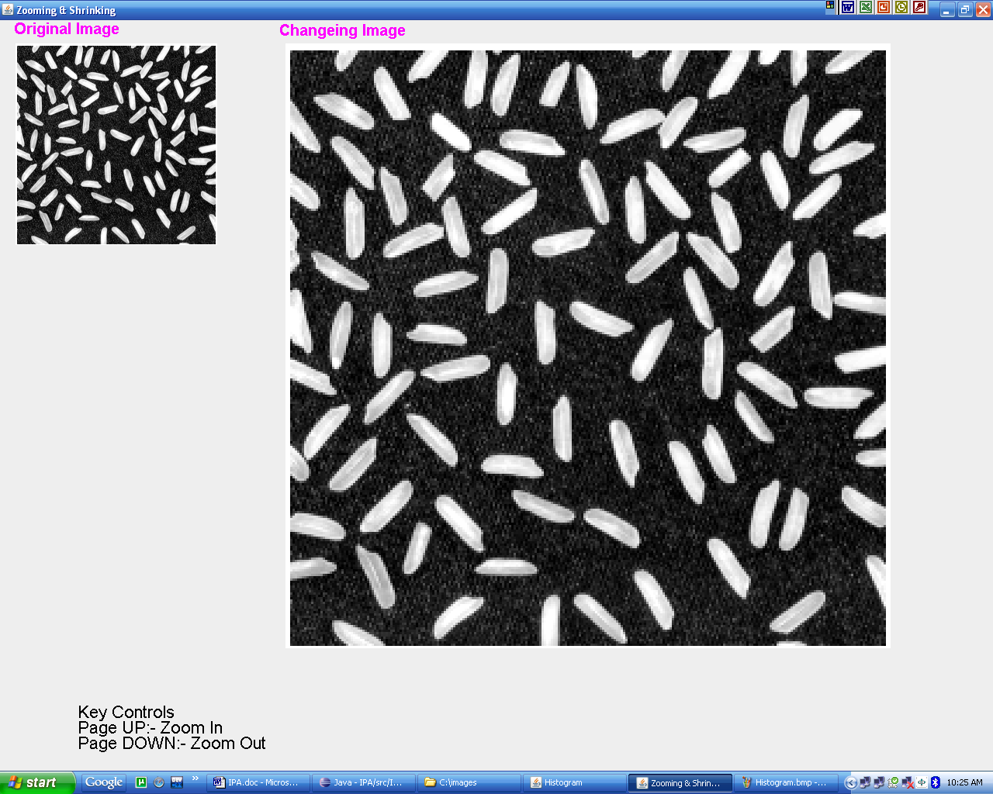
Input/Output:-

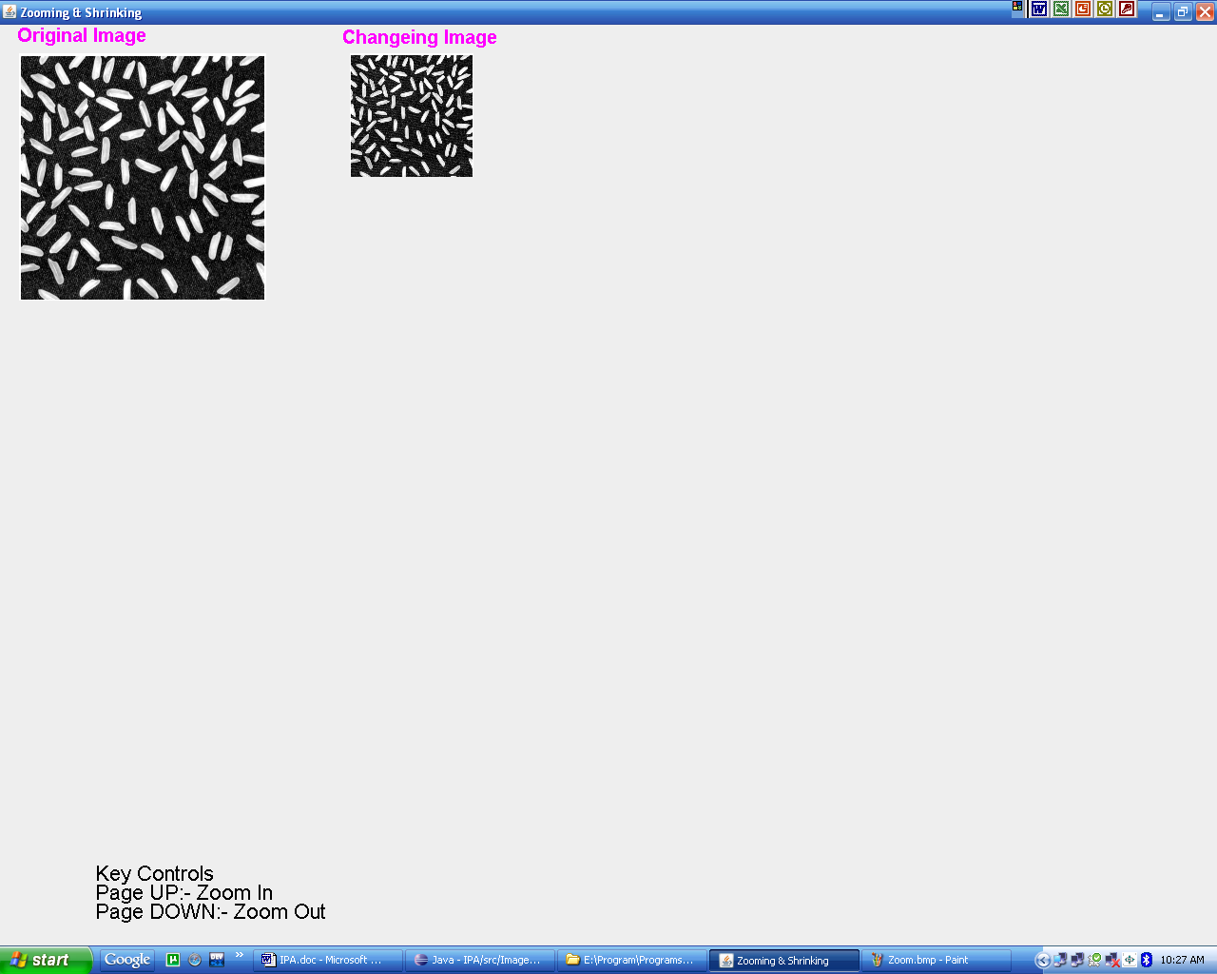

Discussion:-
In the “Zooming and Shrinking” assignment we are using buffer images to store the images(original image and the new modified image). The buffer space is initialized with height and width of the images and they can be modified by the user. After the original image has been buffered it is used to find the new image which is either a result of zoom or a result of shrinking. The buffered space for this assignment are initialized as “TYPE_INT_RGB”. In the function “makeImage()” the new images(zoomed or shrinked) are created depending on key press. The function “drawImages()” draws the images on the screen.
The function “keyPressed()” detects the key pressed on and modifies the zoom or shrink factors accordinly. Also the function checks if the image has been zoomed or shrinked previously then it works on the latest modified image.
The main function loads the image from the specified path, initializes the image to be shown on the screen and creates the frame on which the image will be drawn in the screen. It also sets the visibility of the frame. It also adds the key listener to the frame to respond to the key events.

HISTOGRAM EQUALIZATION OF DIGITAL IMAGES
Theory:-
The histogram equalization is an approach to enhance a given image. The approach is to design a transformation T(.) such that the gray values in the output is uniformly distributed
STEPS TO PERFORM HISTOGRAM EQUALIZATION:
- Let us assume for the moment that the input image to be enhanced has continuous gray values, with r = 0 representing black and r = 1 representing white.
- We need to design a gray value transformation s = T(r), based on the histogram of the input image, which will enhance the image.
- we assume that:
(1) T(r) is a monotonically increasing function for 0 <= r <= 1 (preserves order from black to white).
(2) T(r) maps [0,1] into [0,1] (preserves the range of allowed Gray values).
- Let us denote the inverse transformation by r = T ⁻¹(s) . We assume that the inverse transformation also satisfies the above two conditions.
- We consider the gray values in the input image and output image as random variables in the interval [0, 1].
- Let p_{in}(r) and p_{out}(s) denote the probability density of the Gray values in the input and output images.
- If p_{in}(r) and T(r) are known, and r = T ⁻¹(s) satisfies condition 1, we can write (result from probability theory):
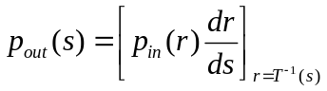

- One way to enhance the image is to design a transformationT(.) such that the gray values in the output is uniformly distributed in [0, 1], i.e. p_{out} (s) = 1, 0 <= s <=1
- This technique is called histogram equalization.

Algorithm:-
Step 1:- Take a sample JPEG Image file ‘ImageOriginal’ from the user.
Step 2:- Create a ‘ImageBuffer’ in the memory and place the ‘ImageOriginal’ in the image buffer.
Step 3:- Find the Height and Width of the image file ‘ImageOriginal’ and assign then to variables height and width respectively.
Step 4:- Convert the ‘ImageOriginal’ to a GrayScale format image and store it in another ImageBuffer ‘ImageGrayScale’.
Step 5 :- Show Both ‘ImageOriginal’ and ‘ImageGrayScale’ .
Step 6:- Calculate r_{k} and n_{k} where r_{k} is the k^{th} intensity value and n_{k} is the number of pixels in the image ‘ImageGrayScale’ having the intensity value r_{k} and normalise histogram components by dividing it by the total number of pixels in the image i.e. height * width of ‘ImageGrayScale’. We store the values of r_{k} , n_{k} and P(r_{k}) = n_{k}/( height * width) in a table T(r_{k}) in the memory.
Step 7:- Plot histogram of the ‘ImageGrayScale’ and display the histogram
Step 8:- Find the histogram equilization transformation for the interval [ 0, L-1 ] (where L is the maximum intensity if the image) as follows :
Step 8.1:- For k = 0 to L-1 do
Step 8.2:- For j = 0 to k do
Step 8.3:- S(k) = S(k) + P(r_{j}) End do
Step 8.4:- S(k) = (L-1)*S(k) End do
Where S(k) is a table in the memory for storing histogram equilization transformation data.
Step 9:- Create a ImageBuffer ‘ImageHistEqualized’ and obtain a processed output image by mapping each pixel in the input image with intensity r_{k} into a corresponding pixel with level s_{k} in the output image .
Step 10:- Show the histogram equalized image ‘ImageHistEqualized’‘.
Step 11:- Plot the histogram of ‘ImageHistEqualized’ and display it.
Step 12:- End.
Code:-

/*Assignment 2:- Histogram Equalization of a Digital Image*/
package ImageProcessingAssignments;

/*Import JAVA and JAVAX packages*/
import java.awt.*;
import java.io.*;
import javax.swing.*;
import java.awt.image.BufferedImage;
import javax.imageio.ImageIO;

/*Declaring the main class that extends JPanel*/
public class Histogram extends JPanel
{
private static final long serialVersionUID = 1L;

/*Declaring BufferImage variables which will store the original image and the modified images*/
//Stores the original image
BufferedImage imageOld;
//Stores the gray style image
BufferedImage imageNew;
//Stores the new image equalized image
BufferedImage imageEq;

/*Declaring variables which will be used for creating the new image*/
//Stores the width of the image
public static int width = 0;
//Stores the height of the image
public static int height = 0;
//Stores the pixel intensity of the image
public static int val = 0;
//Used to calculate the histogram only once
public int flag = 1;
/*Stores the number of pixels of the original image with the intensities equal to the index of the array */
public int arr1[] = new int[256];
/*Stores the number of pixels of the equalized image with the intensities equal to the index of the array*/
public int arr2[] = new int[256];
//Stores the original histogram values
public float pr[] = new float[256];
//Stores the equalized histogram values
public float ps[] = new float[256];

/*Constructor to initialize the variables of the class*/
public Histogram(BufferedImage imageOld)
{
//Initialize the original image
this.imageOld = imageOld;

//Initialize the width of the image
width=imageOld.getWidth();
//Initialize the height of the image
height=imageOld.getHeight();

/*Create the buffer space for the new image to be drawn on the screen for in gray style*/
this.imageNew = new BufferedImage(imageOld.getWidth(),imageOld.getHeight(),BufferedImage.TYPE_INT_RGB);
//Create the buffer space for the equalized image to be drawn on the screen
this.imageEq = new BufferedImage(imageOld.getWidth(),imageOld.getHeight(),BufferedImage.TYPE_INT_RGB);

/*Initializes the array which stores the intensity values of the original gray style */image
for(int i = 0;i < 256;i++)
{
arr1[i] = 0;
}

/*Initializes the array which stores the intensity values of the equalized gray style image*/
for(int i = 0;i < 256;i++)
{
arr2[i] = 0;
}
}

/*Function which is called to paint the screen to display the images at regular intervals*/
protected void paintComponent(Graphics g)
{
/*Passing the graphics display screen components to the superclass function to be displayed on the screen area*/
super.paintComponent(g);

/*Calling the function that creates the gray style image from the original image and then equalizes the image and creates the original and the equalized histogram*/
makeHistogram();

//Calling the function that draws the images on the screen
drawImage(g);

//Calling the function that draws the histograms on the screen
drawHistogram(g);
}

/*Function to create the create the gray image and then calculate the histograms*/
private void makeHistogram()
{
//Declaring local variables
int i = 0,j = 0;
int v = 0;
int valu = 0;
int re = 0,ge = 0,bl = 0;
float s[] = new float[256];
int org_img_arr[][] = new int[width][height];

//Initializing array to be used to calculate the histogram
for(i = 0;i < 256;i++)
{
s[i] = 0;
}

//Calculating the histograms only once and also creating the images only once
if(flag == 1)
{
//Creating the gray scale image
for(i = 0;i < width;i++)
{
for(j = 0;j < height;j++)
{
//Extracting the pixel intensity at a particular point
val = imageOld.getRGB(i,j);
re = (int)(val >> 16) & 0xFF;
ge = (int)(val >> 8) & 0xFF;
bl = (int)(val >>0) & 0xFF;
v = (re+ge+bl)/3;
valu = (v<<16)|(v<<8)|(v);
//Creating the image
imageNew.setRGB(i,j,valu);
}
}

//Creating the intensity map and storing the pixel intensities
for(i = 0;i < width;i++)
{
for(j = 0;j < height;j++)
{
//Extracting the pixel intensity at a particular point
val = imageNew.getRGB(i,j);
re = (val >> 16) & 0xFF;
ge = (val >> 8) & 0xFF;
bl = (val >> 0) & 0xFF;
//Calculating the n for each k of the original image
arr1[(re+ge+bl)/3]++;
//Creates the intensity map array
org_img_arr[i][j] = (re+ge+bl)/3;
}
}

flag = 0;

//Calculating the original histogram of the original image
for(i = 0;i < 256;i++)
{
try
{
pr[i] = (float)arr1[i]*255/(float)(width*height);
}
catch(Exception e)
{
}
}

//Calculating temporary values for the equalized image
for (i = 0;i < 256;i++)
{
for (j = 0;j <= i;j++)
{
s[i] = s[i] + pr[j];
}
}

//Creating the equalized image
for(i = 0;i < width;i++)
{
for(j = 0;j < height;j++)
{
//Extracting the equalized pixel of the equalized image
v = Math.round(s[org_img_arr[i][j]]);
re = (v<<16);
ge = v<<8;
bl = v;
valu = re|ge|bl;

try
{
imageEq.setRGB(i,j,valu);
}
catch(Exception e)
{
}
}
}

//Storing the pixel intensities
for(i = 0;i < width;i++)
{
for(j = 0;j < height;j++)
{
//Extracting the pixel intensity at a particular point
val = imageEq.getRGB(i,j);
re = (val >> 16) & 0xFF;
ge = (val >> 8) & 0xFF;
bl = (val >> 0) & 0xFF;
//Calculating the n for each k of the equalized image
arr2[(re+ge+bl)/3]++;
}
}

//Calculating the equalized histogram of the equalized image
for(i = 0;i < 256;i++)
{
try
{
ps[i] = (float)arr2[i]*255/(float)(width*height);
}
catch(Exception e)
{
}
}
}
}

/*Function to draw the images on the screen*/
private void drawImage(Graphics g)
{
/*Setting the color,font,font type and font size for the text to be displayed on the screen*/
g.setColor(Color.magenta);
g.setFont(new Font("Arial",Font.BOLD, 18));

//Displaying the original image at a particular screen location
g.drawString("Original Image",18,18);
g.drawImage(imageOld,20,20,this);

//Displaying the new gray style image at a particular screen location
g.drawString("Greyscale Image",98+width, 18);
g.drawImage(imageNew,100+width,20,this);

//Displaying the equalized image at a particular screen location
g.drawString("Output Image",196+2*width, 18);
g.drawImage(imageEq,200+2*width,20,this);
}

/*Function to plot the histograms on the screen*/
private void drawHistogram(Graphics g)
{
//Declaring local variables
int i = 0,j = 0;

/*Setting the color,font,font type and font size for the text to be displayed on the screen*/
g.setFont(new Font("Times New Roman",Font.PLAIN,20));

/*Setting the color and drawing the x and y axis for the original histogram on the screen*/
g.setColor(Color.BLUE);
g.fillRect(95,803,520,2);
g.fillRect(95,350,2,454);

//Labeling
g.setColor(Color.BLACK);
g.drawString("Original Histogram:",250,840);

//Drawing the original histogram
for(i = 0,j = 100;i <= 255;i++,j+=2)
{
g.drawLine(j,800-(int)pr[i]*5,j,800);
}

/*Setting the color and drawing the x and y axis for the equalized histogram on the screen*/
g.setColor(Color.BLUE);
g.fillRect(725,803,520,2);
g.fillRect(725,350,2,454);

//Labeling
g.setColor(Color.BLACK);
g.drawString("Equalized Histogram:",880,840);

//Drawing the equalized histogram
for(i = 0,j = 730;i <= 255;i++,j+=2)
{
g.drawLine(j,800-(int)ps[i]*5,j,800);
}

//Displaying the scale used
g.setColor(Color.DARK_GRAY);
g.drawString("Scale:",520,900);
g.drawString("X-Axis: 1 unit= 1 intensity level",520,920);
g.drawString("Y-Axis: 5 unit= 1 normalized histogram level",520,940);
}

/*Main function*/
public static void main(String[] args)
{
/*Loading the image path on which the actios of zooming and shrinking will be done*/
String path = "C:\\images\\01.png";
//Creating a local buffer image in which the image will be loaded
BufferedImage imageOld = null;

//Loading the image onto the buffer
try
{
imageOld = ImageIO.read(new File(path));
}
catch(IOException e)
{
System.out.println("Cannot Read File at location :-"+path);
}

//Initializing the class image variable
Histogram obj = new Histogram(imageOld);
//Creating the frame on which the image will be displayed
JFrame frame = new JFrame("Histogram");
//Setting the default close option
frame.setDefaultCloseOperation(JFrame.EXIT_ON_CLOSE);
//Adding the class object to display the image
frame.add(obj);
//Maximizing the frame by default
frame.setExtendedState(Frame.MAXIMIZED_BOTH);
//Setting the visibility of the frame
frame.setVisible(true);
}
}

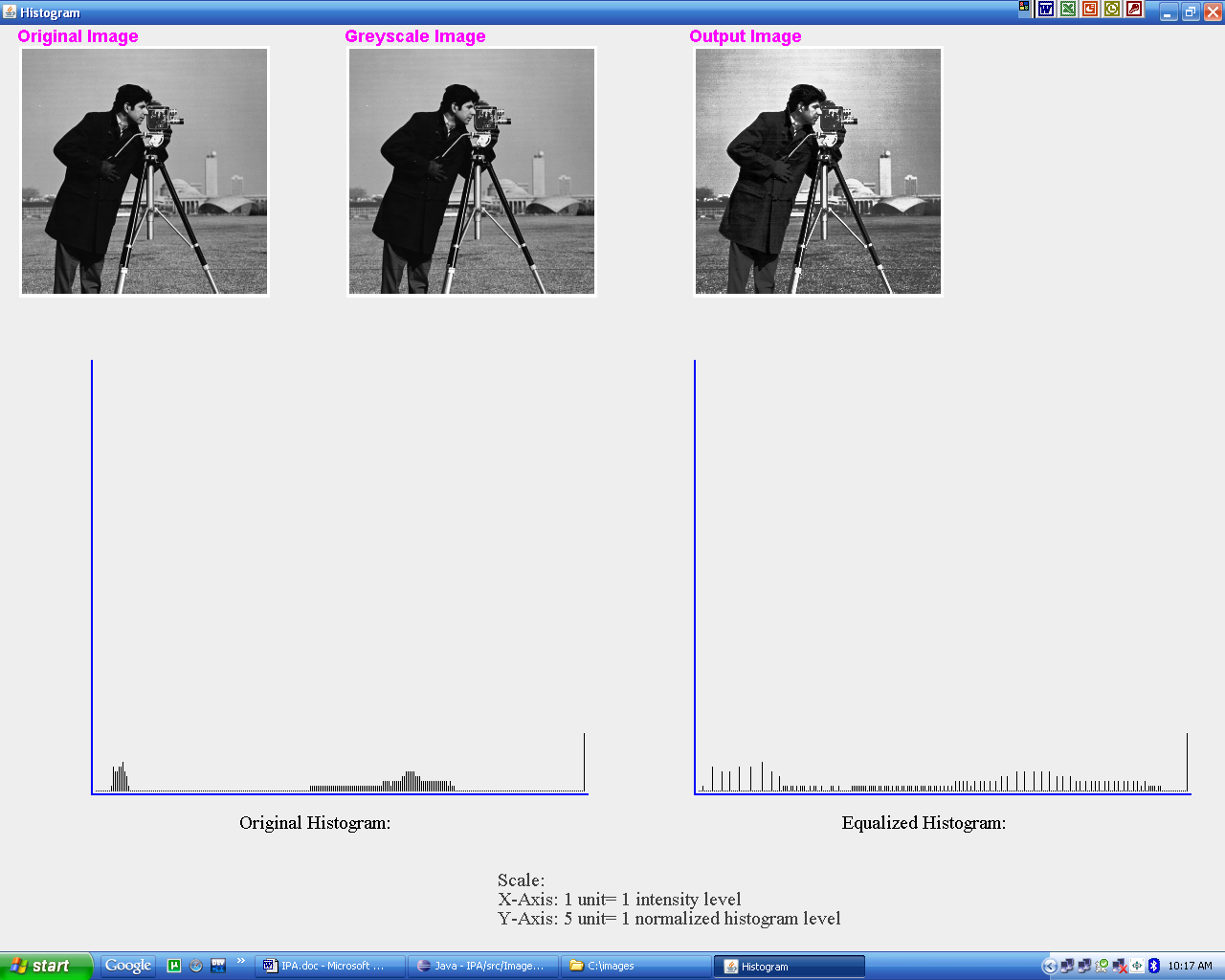
Input/Output:-

Output of the Histogram Equilization Program :
• Given as input is a color Low Contrast Image .
• The Image is converted to Gray Scale format.
• The histogram of the original image matches the charactaristics of a Low Contrast
image as a narrow histogram ia produces and the histogram components are in the middle of the intensity scale.
• Histogram Equalized image is on the far right side which shows a significant improvement in contrast.
• The Equalized Histogram shows that the pixels now occoupy the entire range of the intensity level and are evenly distributed
Discussion:-
In the “Histogram Equalization” assignment we are using buffer images to store the images(original image, gray scale image and the equalized image). The buffer space is initialized with height and width of the images and they can be modified by the user. After the original image has been buffered it is used to find the gray scale image which whose buffered space is denoted as “TYPE_INT_RGB”. Also, the equalized image buffer space is of the type “TYPE_INT_RGB” .Within the ‘paintComponent()’ function the histogram in created and stored in a 1D array. The function draws the histograms(original and equalized) on the screen. The function is also used to draw the image on the screen.
The main function loads the image from the specified path, initializes the image to be shown on the screen and creates the frame on which the image will be drawn in the screen. It also sets the visibility of the frame.

